Software Requirement Specification

# Introduction

In this SRS section, we will explain the technical details about the translation project using AR technology, user requirements and system requirements.

## Purpose of Project

Mobile document translator using AR Application is designed to encourage people to use a foreign language, to make it easier to understand foreign language. In short, people will not have difficulty understanding the language they do not know and they will easily adapt to foreign languages. Translating with the application will be easier. It will provide convenience to people in daily life, business life, school life and many other areas. And it has many useful purposes.

## Target sector or user

There is no target audience limitation for our application. It is designed to be used by people of all ages or education levels or positions.

## What is the Scope of Project?

The aim of the project, as stated above, is designed for anyone who needs to translate. It is aimed to make translation easier and even fun. And the best part is that it saves users time. With the storage process, users can easily return to their previous translations whenever they want.

## References

Some of the utilities we use to develop the application are presented below.

### What is the Augmented Reality Technlogy?

Augmented Reality, one of the most popular topics today, is a type of experience that enriches existing reality. This technology is created by combining the physical elements we perceive in our environment with computer-derived data such as graphics, video, sound, GPS[1]. It provides real-time enrichment of the sensory elements created and their interaction with the physical world. In other words, it is a reality where the real and virtual worlds are not completely separated from each other, on the contrary, they are even more intertwined.In other words, AR is called the phenomenon of superimposing virtual objects on real images by using the object recognition feature of devices. To benefit from this technology; Internet access and devices to define augmented reality (smart phone, smart glasses or tablet) must be available in the current environment.

### What is the Android Studio?

Android Studio is known as the official Integrated Development Environment (IDE) used in Android application development, introduced by Google [2]. It works on any Android device. It provides the fastest tools to develop high quality, high quality resulting applications.Android Studio has migrated to IntelliJ IDEA and developed specifically to develop Android apps. Android Studio has many features that can meet your application development needs, including a smart code editor and debugger, performance analysis tools, emulators and many tools.

### What is the Firebase?

Firebase real-time database is a cloud-based NoSql (Not Only Sql) database system [3]. They can be managed with json parameters without the need for any sql query. In addition to data storage, it enables instant tracking of data changes with asynchronous operation. In its free version, it offers up to 50 people streaming and 100 mb of storage space. its use and interface is very simple.

### What is the Firebase ML Kit?

ML Kit is a mobile SDK that brings Google's machine learning expertise to Android and iOS apps in a powerful yet easy-to-use package [4]. With the Firebase ML Kit, we made a realtime application using machine learning techniques in our project. We did the text reading, detection and saving operations. We took advantage of the API that the Firebase kit offered to users.

# Overall Description

In this section, we will talk about the construction phase of our application, how we carry out the background processes and the general lines of our application.

## Production Perspective

The AR Translator application using Mobile Document Translator is an application that enables people to use foreign languages more easily and comfortably. They will easily perform all translation operations. In short, people will have no difficulty understanding the language they do not know and will easily adapt to foreign languages.

Users who will use Mobile Document Translator Using AR can compare this app with the TextGrabber app, a similar program that has already been done and used now. If users do not speak the same language with people in their area or are traveling, it may be very difficult to listen and understand someone speaking another language, and user may have trouble reading menus, street signs, and electronic manuals in other languages. TextGrabber is a program that translates your phone's camera into the word or text in front of users, which translates it into the language users want to translate. AR Translator application, unlike TextGrabber, saves people from choosing language and automatically perceives the language and offers a nice service.And as we mentioned before, documents are stored in our application. Users can reach whenever they want.

## Product Features

In this section, the database design of the AR translator application explaned(Figure 1).We discussed 6 key issues to present the data structure shown below.

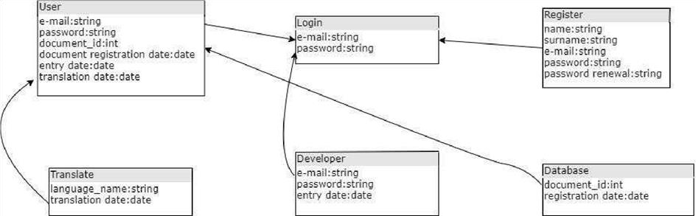

Figure : Database Design

## User classes and characteristics

In this section covered some system design instances with several UML’s and diagrams.

### Entire System

There are 7 basic systems in AR translate application.These are translator AR, login page, register, take a photo, select language, translate document, upload database.When users enter the AR Translate system, users can create a record if they do not have a record.When users enter the system from the home screen, and users select a language.They can add any document to the system if users communication between the user and the server is shown in the following diagram want to take a photo and add it to the system using the camera feature. This data will be registered in the database and will be translated automatically.At the same time, the documents will be available at any time as the data is registered in the database.

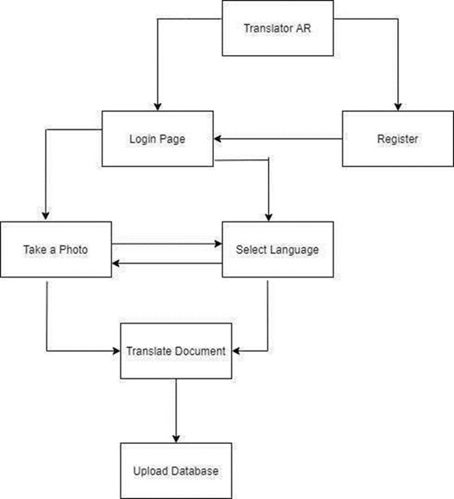

Figure : Use Case Diagram

### User Functioanlites

AR translate application offers its users many features detailed given in the diagram below.

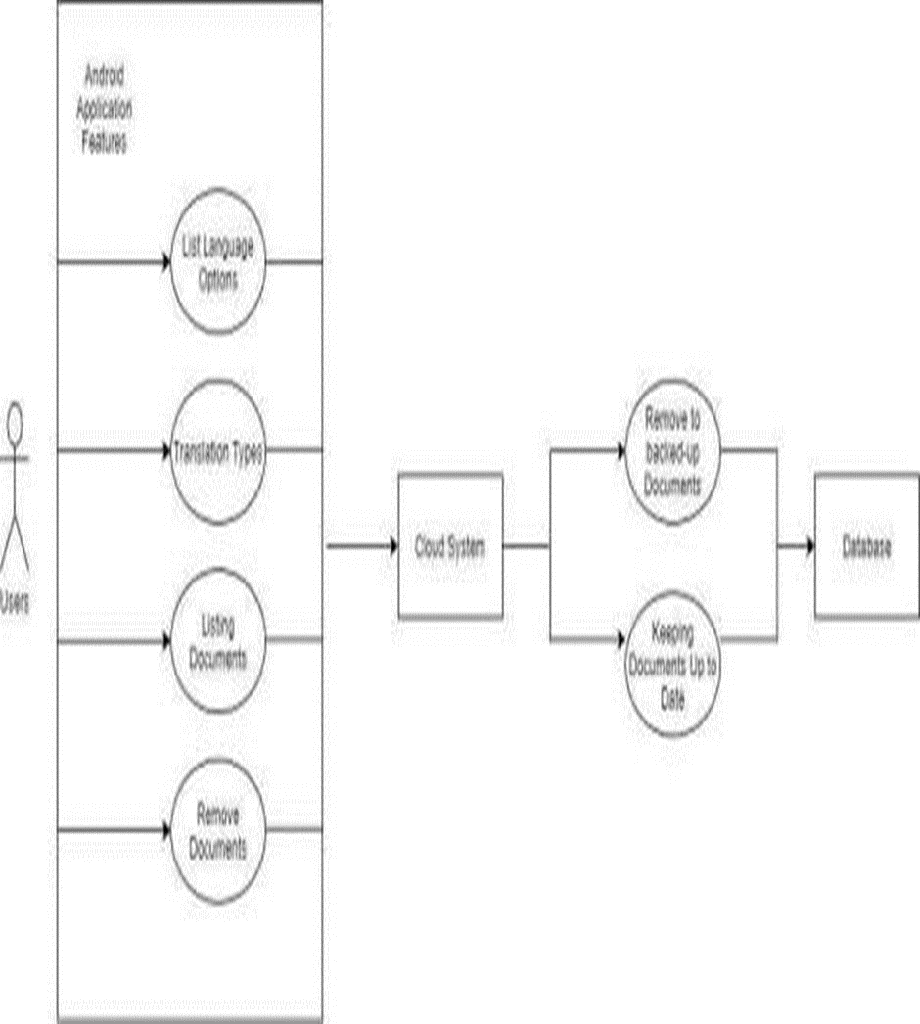

Figure : Use Case Diagram 2

Users of AR translate have access to many features when using the app. These features will be kept up-to-date in the cloud system and database.

### Instance Sequence Diagram

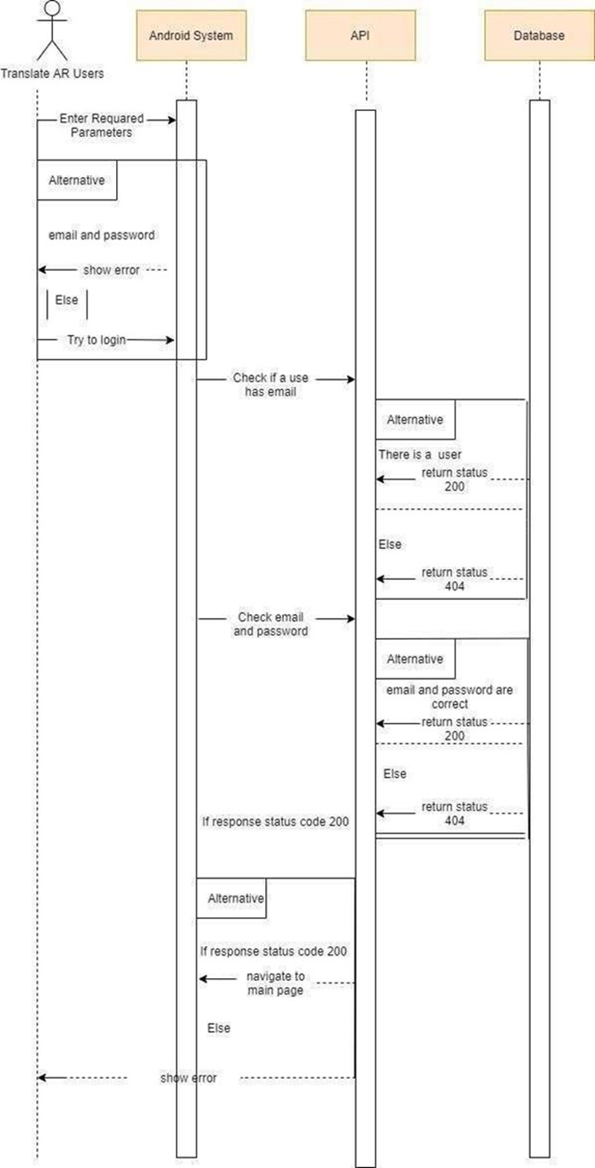

Figure : Sequence Diagram

### Classes

This part we detailed how to class structure UML’s in android platform.

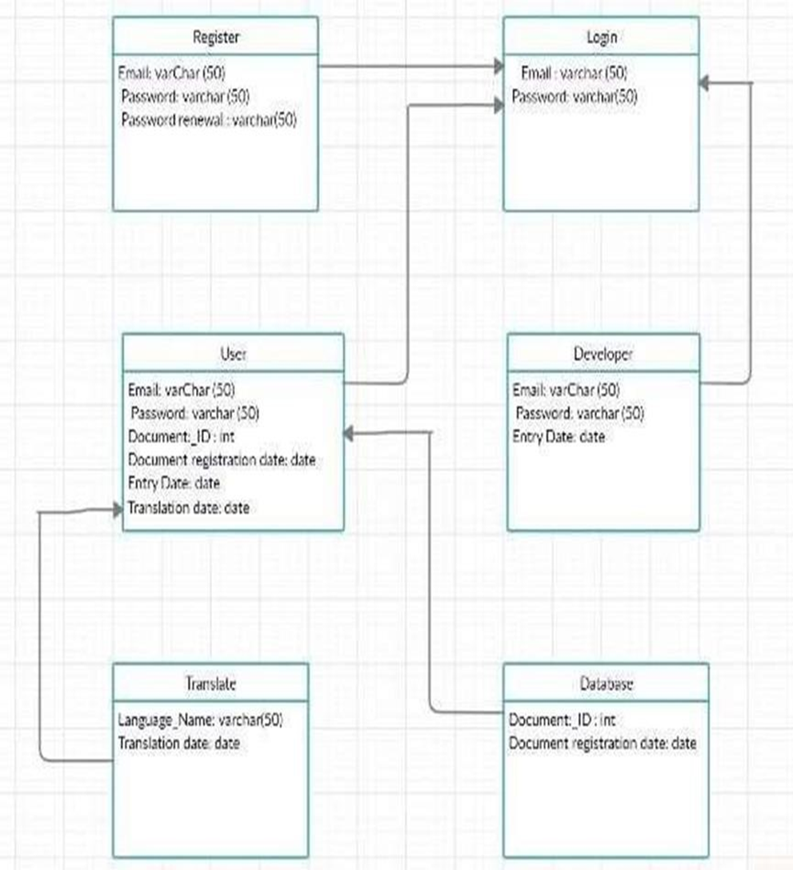

Figure : Classes UML

### User Characteristics

User base will be quite wide. AR Translator application will be found on every phone and will appeal to audiences of all ages. When we develeped to application,to keep the interface as simple as possible, as cater to a wide audience. Another benefit of this is to facilitate the usability of our project.Project will be translated into the desired language with the help of augmented reality technology to the text to be translated by camera. User will choose the language he wants to translate from the option section. In the future, we can develop our project to perceive it on its own.Thanks to our project, users will save time. It will be the choice of users as our project will be useful, fast and reliable.

## Operating Environment

While developing this application, we used Android studio. With this platform, we made a very useful mobile application. It is easy to use and aimed to be used by users of all statuses.

We preferred firebase for database operations of the application. Firebase is useful and has good advantages for developers. Also Firebase ML Kit was used for image and text detection.

## Design and implementation constraints

In this section, process of system design specification is detailed.

### User Interface Upon the First Install

We used mockup to design the user interface of AR Translator. The system will be an Android application. Figures below represent the mockups designs of AR Translator based on the mobile platform interface and tools.Every single detail will be explained step by step with mockup design.

#### Authentication

In AR translator application, users will be able to create new accounts and log into the system with the accounts they own.If users want, they will be able to use the application without creating an account and logging in. But if they do not log into the system, they will not be able to back up the documents they translate.

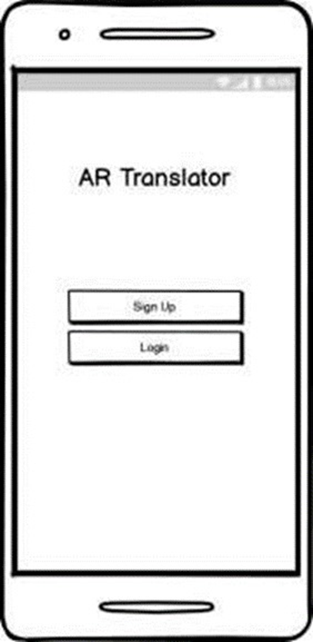

Figure : Mock Up for Authentication

#### Sign Up

Users should go to the registration page whenever they want to register to the system. On this page, the program requests the user 1 valid email address and password. If a registration has not been created with the email address given by the user, the system accepts and the registration of the users is completed.

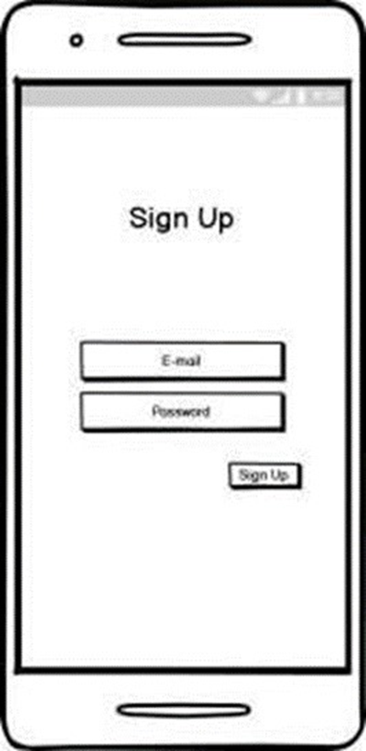

Figure : Mock Up for Sign Up

#### Login

When the users successfully registers to the system or enters the program later, the users can log in to the system using the email address and password they use when registering using the Login page.

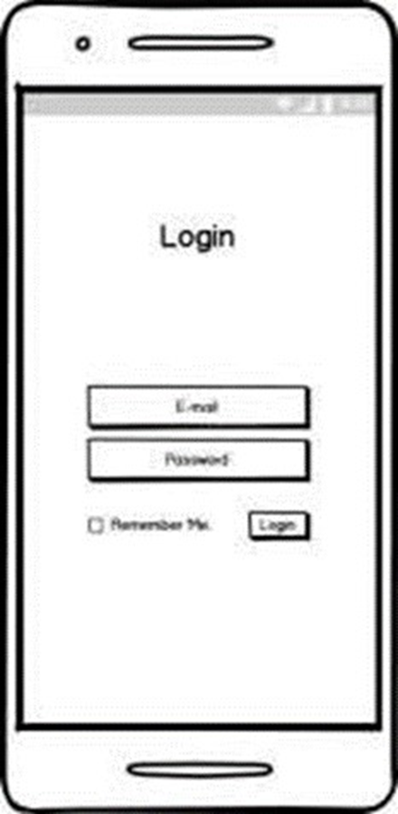

Figure : Mock Up for Login Page

#### Main Page

The main screen of the AR Translate application is as shown in below mock up desing.

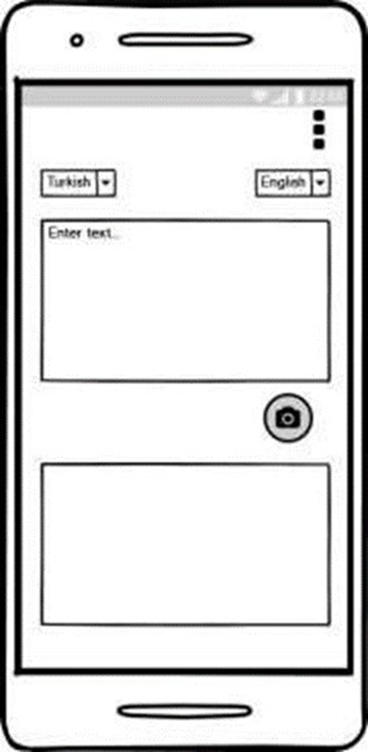

Figure : Mock Up for Main page

##### Options

There is a settings button in the upper right corner of the main screen of the AR translate application. Users can go to the register or login page by clicking this button.

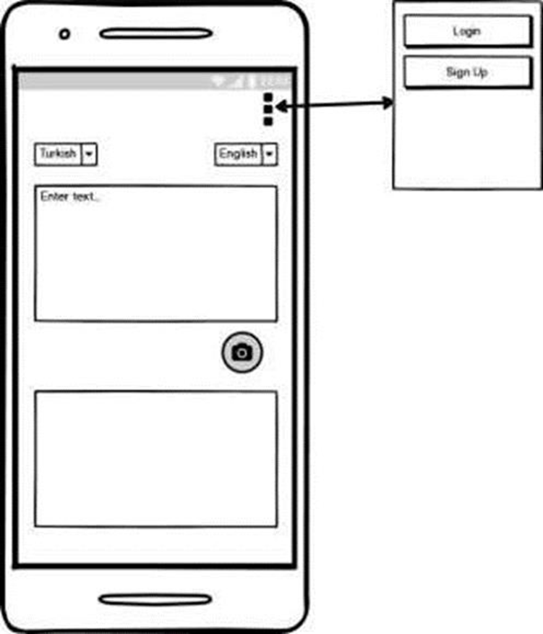

Figure : Mock Up for Options

##### Select Language

There are 2 sections to choose the language in AR translator application. The first of these is to indicate in which language the current word, sentence or text is used, and the other is to translate into which language.In the first option, the user can choose the automatic language detection option and enable the program to detect the language in which the word, sentence or text it wants to translate.

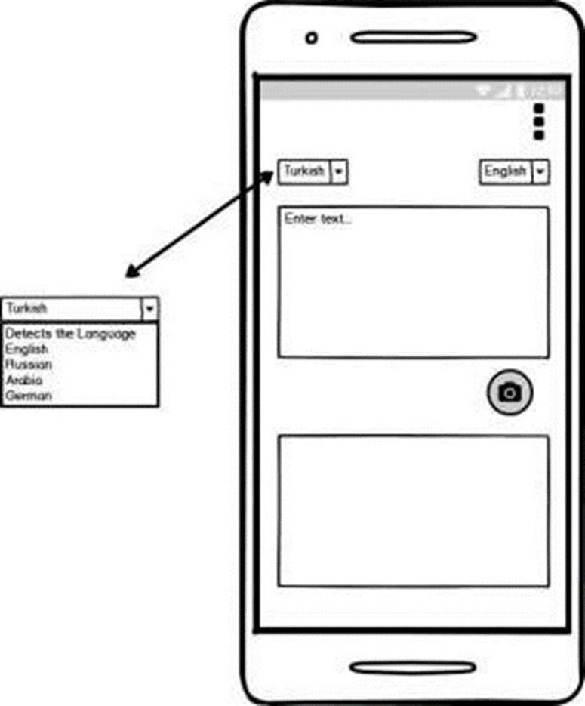

Figure : Mock Up for Options-2

##### Sign Up Options

If the users logs in to the system using the email address and password he used to register to the system, they can go to their own page by clicking the settings button on the upper right of the main screen or log out of their current account.

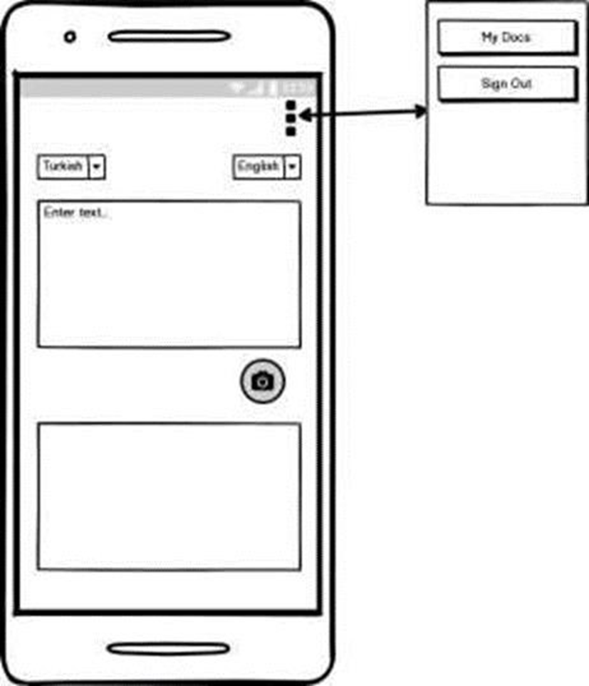

Figure : Mock Up for Sign Up Options

##### Access Camera

The users can go to the translation screen with the camera by clicking the camera button on the main screen.If the users uses the translation part with the camera for the first time, the system asks for one permission. This permission is required for the AR translator application to access the camera of the device. If the users does not accept this permission, the program does not switch to the camera screen. If the users accepts this permission, the program switches to the camera screen.

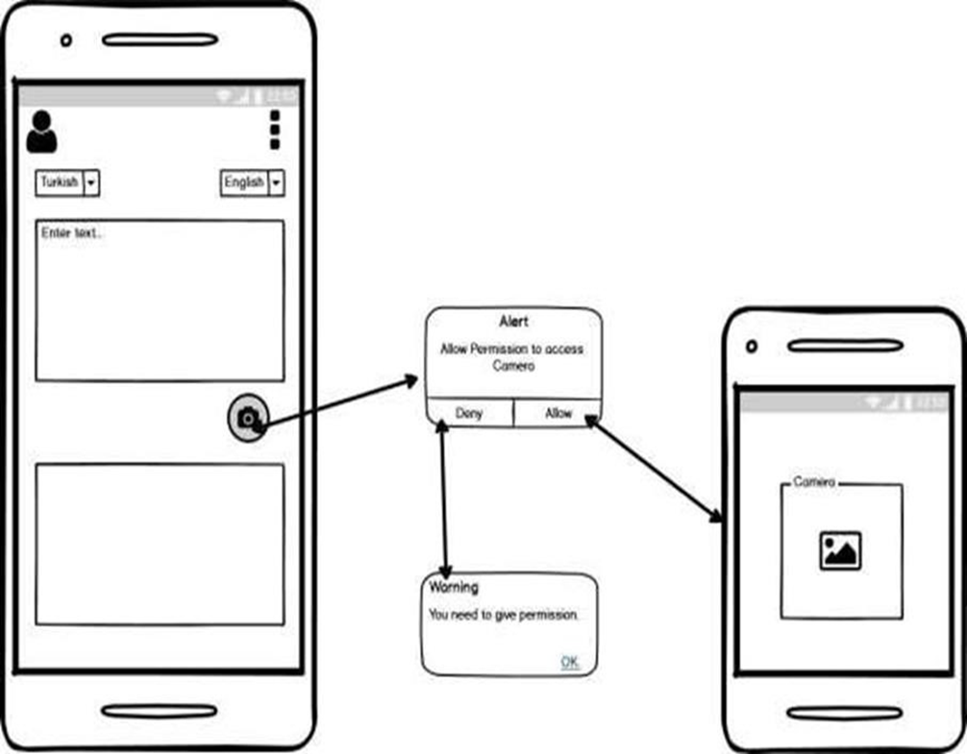

Figure : Mock Up for Access Camera

##### Camera Page

After using the translation with the camera, the users can save the document user translates to her/his own database by clicking the add button in the middle.

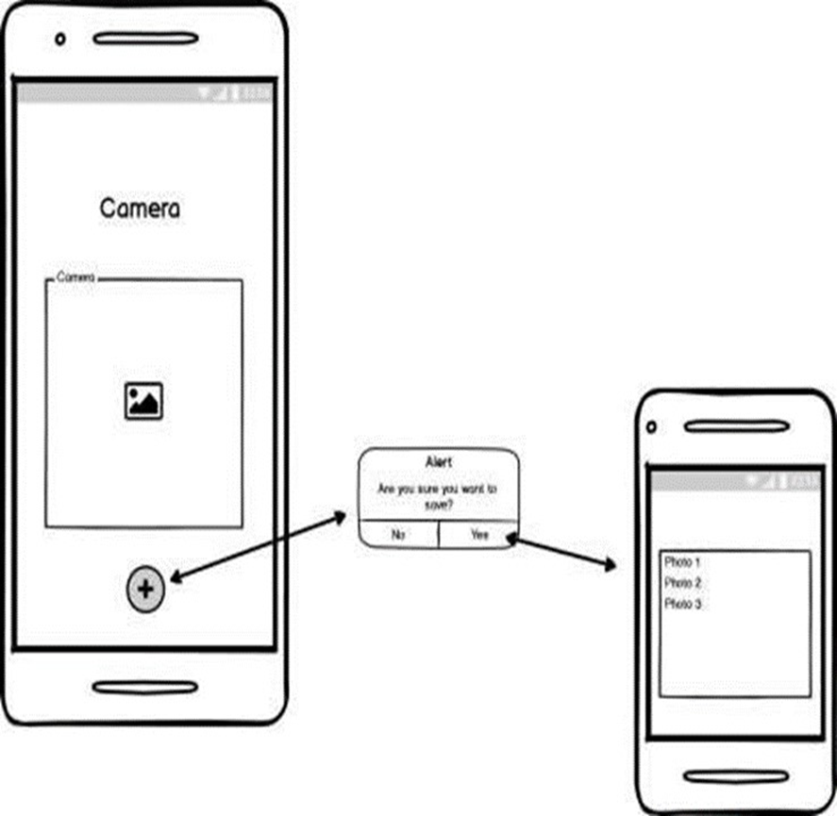

Figure : Mock Up for Camera Page

##### User Documents

The user can go to the profile page and access the pictures that the user has previously saved.

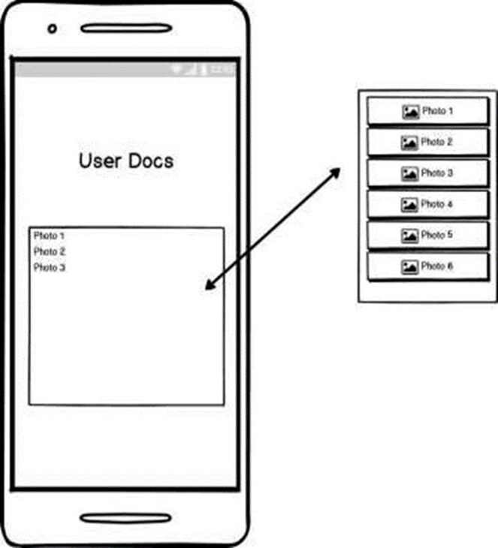

Figure : Mock Up for User Documents

## Assumptions and dependencies

AR Translator Application will develop in the Android operating system. There is also one more constraint, web applications. The Application Program Interface (API) will be designed considering that issue. Application interface will be quite simple for the convenience of users.The user should scan the text they want to translate properly. Otherwise, AR Translation application is incomplete or incorrectly translated. This is a situation we do not want.When we get camera access from the user, We should be careful not to cause any security problems. This is important both for us and for the reliability of AR Translator application.

Actully, internet connection is risk for AR Translator application. Because it is a real time application. When translate documents or stored process needs to internet connection. Unfortunately, it is a creates a bad obstacle.

# System Features and Requirements

## Functional Requirements and System Features

### Profile Management Use Case

Use Case:

• Start

• Start translation

• Exit

Diagram:

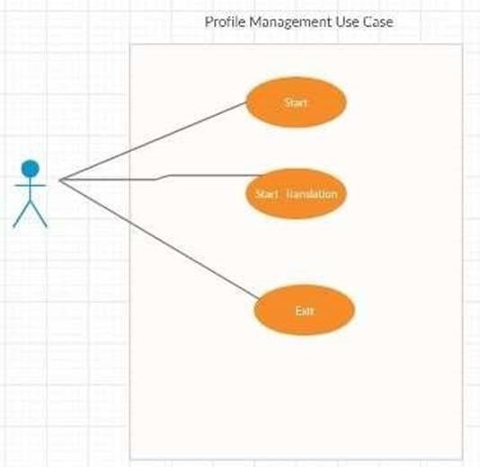

Figure : Profile Management Use Case

Brief Description:

In Profile Management Use Case (Figure 1) explains the basic operations which is related to main screen system of users. Users are able to use following function: Exit apart from these, User can also use start translation function.

### Menu Use Case

Use Case:

• Open camera

• Take a picture

• Scan image

• Select output language

• Get translation

• Search word

• Check internet

• Confirm/Rejection

• Internet

• Giving meaining

Diagram:

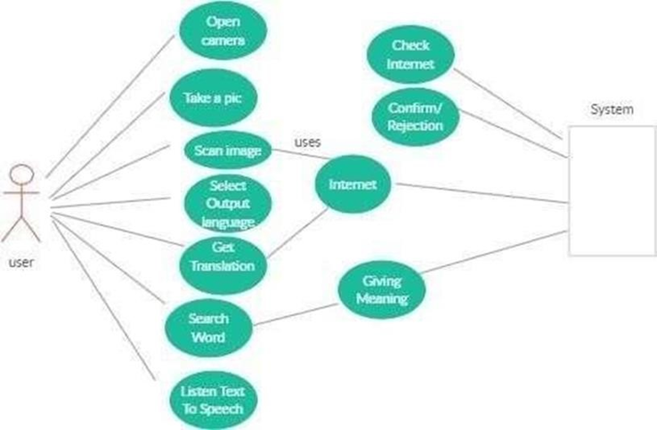

Figure : Menu Use Case

Brief Description:

Figure 2 shows Menu Use Case diagram. When users entered the applications he/she can see this screen. Users can easily start using this application.

# External Interface Requirements

## User Interface

In this section, we will describe the intermediate units that affect AR Translator Application.

## Hardware Interface

System will have hardware requirements on Android and Firebase data base.

## Software Interface

AR Translator project will consist of two main parts: Android studio and Firebase API.

And some software interfaces will be added to the project.

## Communication interfaces

Due to the pandemic, we only communicate online meeting or by phone.

# Non-Functional Requirements

## Performance Requirements